Year R



2025-2026
Meet & Greet Booklet

Welcome to Year R

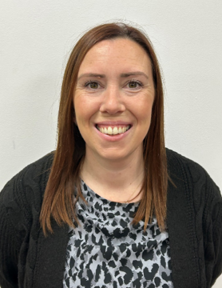
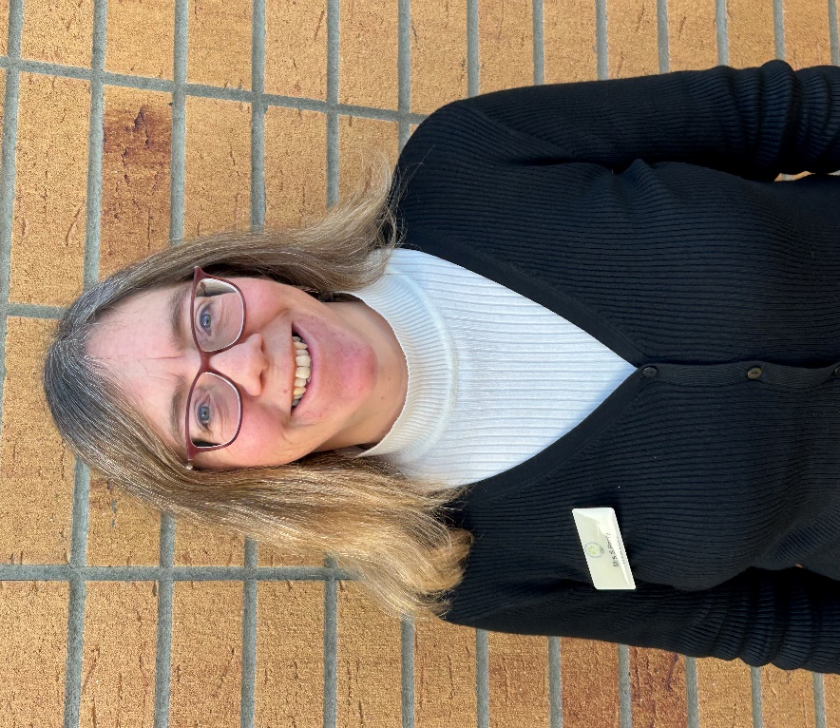

Mrs Parry Mrs Garrett
Class 1 Class 2

Reception Topics 2025-26

Autumn 1 | Autumn 2 | Spring 1 | Spring 2 | Summer 1 | Summer 2
Settling In  – All About Me  - Exploring our environment  The Little Red Hen | Autumn  Christmas | Space  Chinese New Year | Polar Lands  Living Eggs/Easter | Under the Sea | Owls  Mythical creatures – dragons and unicorns
Developing growth mindset - The dot and Ish
Year R Dress up days 2025/26
Autumn 1 | Autumn 2 | Spring 1 | Spring 2 | Summer 1 | Summer 2
 |  | Chinese New Year children to wear red.

Year R Educational Visit/Visitors 2025-26

Autumn 1 | Autumn 2 | Spring 1 | Spring 2 | Summer 1 | Summer 2
 |  |  |  |  | The Hawk Conservatory (Owls)

Early Learning Goals

Communication and Language Development
Listening, Attention and Understanding | Children at the expected level of development will:  - Listen attentively and respond to what they hear with relevant questions, comments and actions when being read to and during whole class discussions and small group interactions;  - Make comments about what they have heard and ask questions to clarify their understanding;  - Hold conversation when engaged in back-and-forth exchanges with their teacher and peers.
Speaking | Children at the expected level of development will:  - Participate in small group, class and one-to-one discussions, offering their own ideas, using recently introduced vocabulary;  - Offer explanations for why things might happen, making use of recently introduced vocabulary from stories, non-fiction, rhymes and poems when appropriate;  - Express their ideas and feelings about their experiences using full sentences, including use of past, present and future tenses and making use of conjunctions, with modelling and support from their teacher.

Personal, Social and Emotional Development
Self-Regulation | Children at the expected level of development will:  - Show an understanding of their own feelings and those of others, and begin to regulate their behaviour accordingly;  - Set and work towards simple goals, being able to wait for what they want and control their immediate impulses when appropriate;  - Give focused attention to what the teacher says, responding appropriately even when engaged in activity, and show an ability to follow instructions involving several ideas or actions.
Managing Self | Children at the expected level of development will:  - Be confident to try new activities and show independence, resilience and perseverance in the face of challenge;  - Explain the reasons for rules, know right from wrong and try to behave accordingly;  - Manage their own basic hygiene and personal needs, including dressing, going to the toilet and understanding the importance of healthy food choices.
Building Relationships | Children at the expected level of development will:  - Work and play cooperatively and take turns with others;  - Form positive attachments to adults and friendships with peers;  - Show sensitivity to their own and to others’ needs.

Physical Development
Gross Motor Skills | Children at the expected level of development will:  - Negotiate space and obstacles safely, with consideration for themselves and others;  - Demonstrate strength, balance and coordination when playing;  - Move energetically, such as running, jumping, dancing, hopping, skipping and climbing.
Fine Motor Skills | Children at the expected level of development will:  - Hold a pencil effectively in preparation for fluent writing – using the tripod grip in almost all cases;  - Use a range of small tools, including scissors, paint brushes and cutlery;  - Begin to show accuracy and care when drawing.

Literacy
Comprehension | Children at the expected level of development will:  - Demonstrate understanding of what has been read to them by retelling stories and narratives using their own words and recently introduced vocabulary;  - Anticipate – where appropriate – key events in stories;  - Use and understand recently introduced vocabulary during discussions about stories, non-fiction, rhymes and poems and during role-play.
Word Reading | Children at the expected level of development will:  - Say a sound for each letter in the alphabet and at least 10 digraphs;  - Read words consistent with their phonic knowledge by sound-blending;  - Read aloud simple sentences and books that are consistent with their phonic knowledge, including some common exception words.
Writing | Children at the expected level of development will:  - Write recognisable letters, most of which are correctly formed;  - Spell words by identifying sounds in them and representing the sounds with a letter or letters;  - Write simple phrases and sentences that can be read by others.

Mathematics
Number | Children at the expected level of development will:  - Have a deep understanding of number to 10, including the composition of each number;  - Subitise (recognise quantities without counting) up to 5;  - Automatically recall (without reference to rhymes, counting or other aids) number bonds up to 5 (including subtraction facts) and some number bonds to 10, including double facts.
Numerical Patterns | Children at the expected level of development will:  - Verbally count beyond 20, recognising the pattern of the counting system;  - Compare quantities up to 10 in different contexts, recognising when one quantity is greater than, less than or the same as the other quantity;  - Explore and represent patterns within numbers up to 10, including evens and odds, double facts and how quantities can be distributed equally.

Understanding the World
Past and Present | Children at the expected level of development will:  - Talk about the lives of the people around them and their roles in society;  - Know some similarities and differences between things in the past and now, drawing on their experiences and what has been read in class;  - Understand the past through settings, characters and events encountered in books read in class and storytelling.
People, Culture and Communities | Children at the expected level of development will:  - Describe their immediate environment using knowledge from observation, discussion, stories, non-fiction texts and maps;  - Know some similarities and differences between different religious and cultural communities in this country, drawing on their experiences and what has been read in class;  - Explain some similarities and differences between life in this country and life in other countries, drawing on knowledge from stories, non-fiction texts and, when appropriate, maps.
The Natural World | Children at the expected level of development will:  - Explore the natural world around them, making observations and drawing pictures of animals and plants;  - Know some similarities and differences between the natural world around them and contrasting environments, drawing on their experiences and what has been read in class;  - Understand some important processes and changes in the natural world around them, including the seasons and changing states of matter.

Expressive Arts and Design
Creating with Materials | Children at the expected level of development will:  - Safely use and explore a variety of materials, tools and techniques, experimenting with colour, design, texture, form and function;  - Share their creations, explaining the process they have used;  - Make use of props and materials when role playing characters in narratives and stories.
Being Imaginative and Expressive | Children at the expected level of development will:  - Invent, adapt and recount narratives and stories with peers and their teacher;  - Sing a range of well-known nursery rhymes and songs;  - Perform songs, rhymes, poems and stories with others, and, when appropriate, try to move in time with music.

Behaviour Policy
We have chosen three rules through which the code of conduct is promoted in all aspects of school life.
Be
• Ready
• Respectful
• Safe

Incentives and Rewards
A major aim of the school policy is to encourage children to practice good behaviour by operating a system of recognition and reward. All staff give verbal or written recognition as often as possible. Other rewards include:
- Positive notes home
- Beads in a bottle (class reward)
- Certificates
- Hot Chocolate Fridays
The mindfulness room
At breaktimes and lunchtimes, a calm room is available for children to come to if they are feeling angry or upset and need to calm down.
Sanctions
Our sanctions policy concentrates on encouraging children to make sensible choices and putting things right when possible. If a child breaks a school rule (e.g. by disturbing others through chatting, calling out etc) the ‘Sanctions Ladder’ should be followed with children moving to the next point on the ladder if the behaviour continues or worsens.
Before going on to the “ladder”, the teacher will notice by giving the child a look or let the child know that they are making a poor choice.
If the child continues to break school rules…
1. Reminder
2. Warning
3. Time out or move in class
4. Repair (discuss behaviour with teacher and consider how best to repair the problem)

If you are sent out of your classroom, your teacher will speak to your parents.
If your behaviour does not improve you will discuss this with your class teacher and Head Teacher and your parents will be contacted.
Repeated classroom disruption may result in a behaviour chart or plan being implemented.
If a child wastes time or does not complete work that has been set, the work will be completed in the child’s own time i.e. at break or lunchtime.

Serious Breaches of the Behaviour Policy
For more serious behaviour e.g. swearing, spitting, causing physical harm, damaging school property, which goes beyond the breaking of class rules, the adult dealing with the situation will need to use their professional judgement over the best course of action ensuring the safety of children and staff first.

