Year 1



2025-2026
Meet & Greet Booklet

Welcome to Year 1

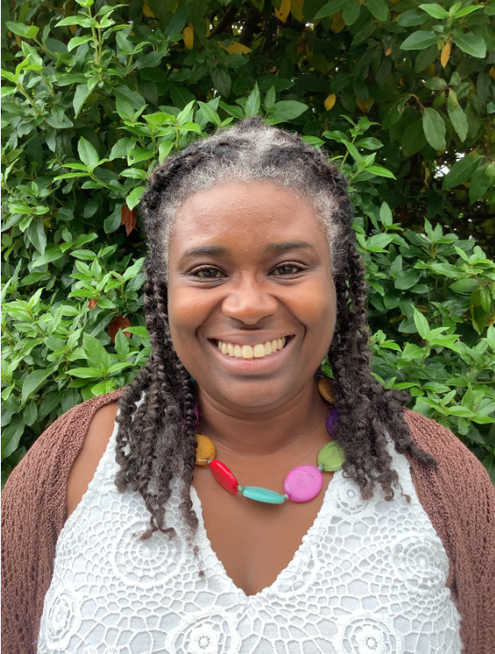
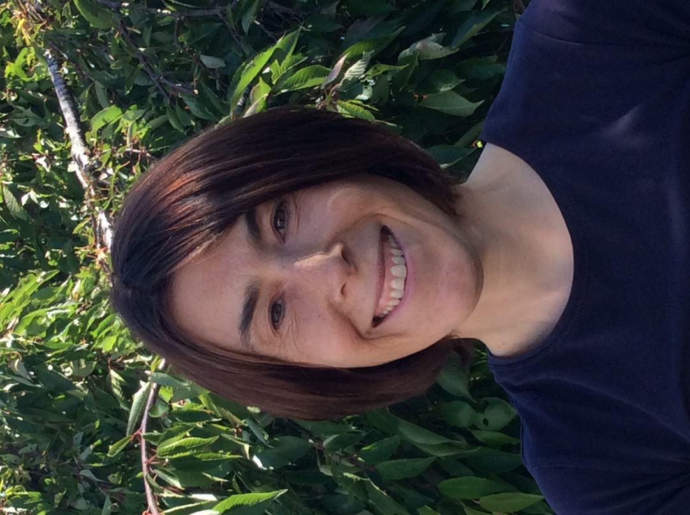
Mrs Barton Mrs Mason
Class 3 Class 4

Year 1 Curriculum Overview 2025-26

Year 1 | Autumn 1  The Three Little pigs | Autumn 2  Toys | Spring 1  Florence Nightingale and Mary Seacole | Spring 2  Animals | Summer 1  Jack and the Beanstalk | Summer 2  Plants
History |  | Changes in Toys over time | Florence Nightingale, Mary Seacole and Edith Cavell
Geography | Weather |  |  | Weather | Continents & Oceans | Our school  Physical & Human Features
Science | Everyday Materials | Seasonal Change | Human Body  Body parts and senses | Classifying Animals | Plants | Plants
DT and Nutrition |  | Making own Toy Puppet | Moving Pictures  Boris the Robot |  |  | Cooking and Nutrition  Fruit Salad
Art and Design | Sculpture  Clay | Textiles  Sewing | Painting  Colour Mixing  Shading | Textiles  Collage | Printing | Drawing  Sketching
Physical Education | Orienteering  Dance: 3 Little Pigs | Games: Throwing & catching  Dance: Toys | Games: Football  Gym: Shape and Balance | Games: Spatial Awareness  Gym: Wall Bars | Games: Athletics  Dance: Jack and the Beanstalk | Games: Tennis  Gym: Key Steps Body Management – Step 1
Heart Smart | Get Heart Smart | Don’t Forget To Let Love In! | Too Much Selfie Isn’t Healthy! | Don’t Rub It In, Rub It Out | Fake Is A Mistake | ‘No Way Through’, Isn’t True
RE | Belonging - Judaism | Symbol of Light | Change | Welcoming | Precious | Special Places
Music | The Old Castle | Christmas is Coming | Toys | As Cold as Ice | Sound Explorers | Can I be helpful too?
Computing | What is a computer? | Modern Tales | My friend the Robot | Drawing maths | My online life

Year 1 Educational Visit/Visitors 2024/25

Year 1 | Autumn 1 | Autumn 2 | Spring 1 | Spring 2 | Summer 1 | Summer 2
 | St Mary’s Church  Harvest |  | Open Box workshop-  Florence Nightingale |  |  | Hilliers Garden Romsey*  St Mary’s Church (RE)

Year 1 Reading Key Objectives

Speedily read all basic phoneme/graphemes
Read accurately by blending known GPCs
Read common exception words
Read common suffixes
Read multi-syllable words containing known GPCs
Read contractions and understand use of apostrophe
Retell familiar stories and traditional tales
Recognise and join in with predictable phrases
Recite some poetry by heart
Understand texts based on prior knowledge or provided information
Correct inaccurate reading by check for sense
Discuss the significance of title and events
Make inferences on the basis of what is said and done
Make predictions based on reading so far
Explain clearly understanding of what is read to them

Year 1 Writing Behaviours & Key Objectives

Writing Behaviours:
Generate ideas through discussion, role play and drama
Plan writing using story maps, picture cues and word banks
Compose sentences orally before writing
Review and refine by reading aloud their writing clearly
Discuss what they have written
Key objectives:
Sequence sentences to form short narratives
Spell words using the standard phonemes
Spell common exception words & days of the week
Spell the days of the week
Understand spelling rules for adding ‘s’
Use suffixes –ing, -ed, -er and -est
Sit and hold writing implement correctly
Begin to form lower-case letters correctly
Form capital letters and digits 0-9
Join words and clauses using 'and'

Maths Mastery

The National Curriculum emphasises the importance of all children mastering the content taught each year and discourages the acceleration of children into content from subsequent years.
We aim for all children to
• become fluent in the fundamentals of mathematics, experience varied and frequent practice with increasingly complex problems over time in order to develop conceptual understanding and the ability to recall and apply knowledge rapidly and accurately
• reason mathematically by following a line of enquiry, spotting relationships and generalisations, and developing justification or proof using mathematical language
• solve problems by applying their mathematics to a variety of routine and non-routine problems with increasing sophistication, including breaking down problems into a series of simpler steps and persevering in seeking solutions.

Year 1 Key Objectives

Count, read and write numbers to 100 in numerals
Read and write mathematical symbols: +, - and =
Identify "one more" and "one less"
Use number bonds and subtraction facts within 20
Add and subtract 1-digit and 2-digit numbers to 20, including zero
Recognise, find and name a half
Recognise, find and name a quarter
Measure and begin to record length, mass, volume and time
Recognise and know the value of all coins and notes
Use language to sequence events in chronological order
Recognise and use language relating to dates
Tell the time to the half-hour, including drawing clocks
Recognise and name common 2-D shapes
Recognise and name common 3-D shapes

Year 1 Science Key Objectives

Use different approaches to answer scientific questions
Carry out simple tests
Organise objects or materials into groups
Name the main parts of plants and trees
Name the main parts of the body, including those related to the 5 senses
Distinguish between an object and the material from which it is made
Describe the simple physical properties of a variety of everyday materials
Describe how the weather varies with the season

Year 1 Spelling

Statutory requirements |  | Rules and guidance (non-statutory) | Example words (non-statutory)
The sounds /f/, /l/, /s/, /z/ and /k/ spelt ff, ll, ss, zz and ck |  | The /f/, /l/, /s/, /z/ and /k/ sounds are usually spelt as ff, ll, ss, zz and ck if they come straight after a single vowel letter in short words. Exceptions: if, pal, us, bus, yes. | off, well, miss, buzz, back
The /ŋ/ sound spelt n before k |  |  | bank, think, honk, sunk
Division of words into syllables |  | Each syllable is like a ‘beat’ in the spoken word. Words of more than one syllable often have an unstressed syllable in which the vowel sound is unclear. | pocket, rabbit, carrot, thunder, sunset

-tch |  | The /tʃ/ sound is usually spelt as tch if it comes straight after a single vowel letter. Exceptions: rich, which, much, such. | catch, fetch, kitchen, notch, hutch
The /v/ sound at the end of words |  | English words hardly ever end with the letter v, so if a word ends with a /v/ sound, the letter e usually needs to be added after the ‘v’. | have, live, give
Adding s and es to words (plural of nouns and the third person singular of verbs) |  | If the ending sounds like /s/ or /z/, it is spelt as –s. If the ending sounds like /ɪz/ and forms an extra syllable or ‘beat’ in the word, it is spelt as –es. | cats, dogs, spends, rocks, thanks, catches
Adding the endings –ing, –ed and –er to verbs where no change is needed to the root word |  | –ing and –er always add an extra syllable to the word and –ed sometimes does.  The past tense of some verbs may sound as if it ends in /ɪd/ (extra syllable), /d/ or /t/ (no extra syllable), but all these endings are spelt –ed.  If the verb ends in two consonant letters (the same or different), the ending is simply added on. | hunting, hunted, hunter, buzzing, buzzed, buzzer, jumping, jumped, jumper
Adding –er and –est to adjectives where no change is needed to the root word |  | As with verbs (see above), if the adjective ends in two consonant letters (the same or different), the ending is simply added on. | grander, grandest, fresher, freshest, quicker, quickest

Statutory requirements |  | Rules and guidance (non-statutory) | Example words (non-statutory)
Words ending –y (/i:/ or /ɪ/) |  |  | very, happy, funny, party, family
New consonant spellings ph and wh |  | The /f/ sound is not usually spelt as ph in short everyday words (e.g. fat, fill, fun). | dolphin, alphabet, phonics, elephant  when, where, which, wheel, while
Using k for the /k/ sound |  | The /k/ sound is spelt as k rather than as c before e, i and y. | Kent, sketch, kit, skin, frisky
Adding the prefix –un |  | The prefix un– is added to the beginning of a word without any change to the spelling of the root word. | unhappy, undo, unload, unfair, unlock
Compound words |  | Compound words are two words joined together. Each part of the longer word is spelt as it would be if it were on its own. | football, playground, farmyard, bedroom, blackberry
Common exception words |  | Pupils’ attention should be drawn to the grapheme-phoneme correspondences that do and do not fit in with what has been taught so far. | the, a, do, to, today, of, said, says, are, were, was, is, his, has, I, you, your, they, be, he, me, she, we, no, go, so, by, my, here, there, where, love, come, some, one, once, ask, friend, school, put, push, pull, full, house, our – and/or others, according to the programme used
Year 1 Spelling (cont’d)

Year 1 Grammar & Punctuation

Sentence Structure
How words can combine to make sentences
Joining words and joining clauses using and

Text Structure
Sequencing sentences to form short narratives

Punctuation
Separation of words with spaces
Introduction to capital letters, full stops, question marks and exclamation marks to demarcate sentences
Capital letters for names and for the personal pronoun I

Terminology for Pupils
letter, capital letter, word, singular, plural, sentence, punctuation, full stop, question mark, exclamation mark

Behaviour Policy
We have chosen three rules through which the code of conduct is promoted in all aspects of school life.
Be
• Ready
• Respectful
• Safe

Incentives and Rewards
A major aim of the school policy is to encourage children to practice good behaviour by operating a system of recognition and reward. All staff give verbal or written recognition as often as possible. Other rewards include:
- Positive notes home
- Beads in a bottle (class reward)
- Certificates
- Hot Chocolate Fridays
The mindfulness corner
In the classroom, a calm area is available for children to come to if they are feeling angry or upset and need to calm down.
Sanctions
Our sanctions policy concentrates on encouraging children to make sensible choices and putting things right when possible. If a child breaks a school rule (e.g. by disturbing others through chatting, calling out etc) the ‘Sanctions Ladder’ should be followed with children moving to the next point on the ladder if the behaviour continues or worsens.
Before going on to the “ladder”, the teacher will notice by giving the child a look or let the child know that they are making a poor choice.
If the child continues to break school rules…
1. Reminder
2. Warning
3. Time out or move in class
4. Repair (discuss behaviour with teacher and consider how best to repair the problem)

If you are sent out of your classroom, your teacher will speak to your parents.
If your behaviour does not improve you will discuss this with your class teacher and Head Teacher and your parents will be contacted.
Repeated classroom disruption may result in a behaviour chart or plan being implemented.
If a child wastes time or does not complete work that has been set, the work will be completed in the child’s own time i.e. at break or lunchtime.

Serious Breaches of the Behaviour Policy
For more serious behaviour e.g. swearing, spitting, causing physical harm, damaging school property, which goes beyond the breaking of class rules, the adult dealing with the situation will need to use their professional judgement over the best course of action ensuring the safety of children and staff first.

