Year 3



2025-2026
Meet & Greet Booklet

Welcome to Year 3

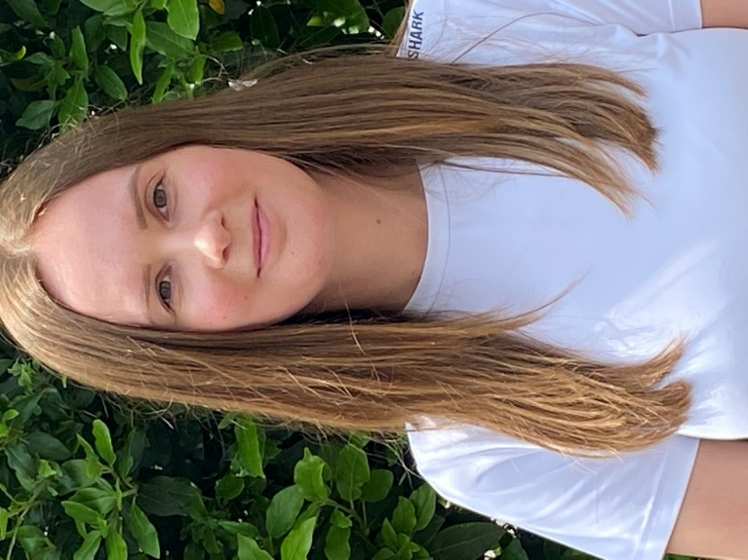
Class 7  Miss Cox- Class teacher  Mrs Middleton- LSA | Class 8  Mrs Morgan- Class teacher  Mrs Restell- LSA

Year 3 Curriculum Overview 2025-26

 | Autumn 1  Stone Age to Iron Age | Autumn 2  Stone Age to Iron Age | Spring 1  Marvellous Me | Spring 2  Local Explorers | Summer 1  Ancient Egypt | Summer 2  Ancient Egypt
History | Stone Age to Iron Age | Stone Age to Iron Age |  |  | Ancient Egypt | Ancient Egypt
Geography |  |  |  | Local study- Overton | Deserts and the River Nile | Deserts and the River Nile
Science | Rocks and fossils | Forces and Magnets | The Human Body | Light | Plants and soils | Plants and soils
DT and Nutrition |  | Christmas Cards – Levers and Linkages | Cooking: Healthy Soup – cutting, chopping and dicing |  |  | Egyptian Artefacts- Strengthening and Reinforcing
Art and Design | Sculpture: Clay Diya Pots | Drawing: Stone Age Artefacts | Painting: Jon Cooper abstract portraits |  | Printing: mono-printing inspired by Angie Lewin
Physical Education | Games: Orienteering  Dance: Street Dance | Games: Football  Gym: Responding to Music | Games: Rugby  Dance: River themed Dance | Games: Tennis  Gym: Shape and Balance | Games: Athletics  Dance: Egyptian themed | Games: Cricket /Rounders  Gym: Key Steps Body Management- Balance
Heart Smart | Get Heart Smart | Don’t Forget To Let Love In | Too Much Selfie Isn’t Healthy | Don’t Hold on to What’s Wrong | Fake Is a Mistake | No Way Through Isn’t Through
RE | Good vs Evil  Diwali, Hinduism | Holy-Mary, Mother of God | Protection | Rituals | Ceremonies: Death ceremony | Interpretation  Perceptions of God
Music | Mystic Moments and  Listen to me | Winter and Listen to me | Animal Fair and Listen to me | British Melting Pot and  Listen to me | Adverts and Listen to me | Class Orchestra and Listen to me
MFL | France  Greetings  Numbers 1-12 | Days of the week and fruits linking to the text Hungry Caterpillar  Christmas | Numbers 1-20  Colours, linking to the text Rainbow fish | Parts of the body | Pets/ animals and habitats | Colours, fruits and animals, linking to the text Handa’s surprise
Computing | Dancing Robot: coding (computer science) | Keyboard Adventures: mastering the use of a keyboard | Be Digitally Awesome: word processing, spreadsheets and presentation apps (Information technology) | Rainforests: Virtual Reality and Augmented Reality (Information technology) | My online life: e-safety (Digital literacy) | My online life: e-safety (Digital literacy)

Year 3 Educational Visit/Visitors 2025-2026

Year 3 | Autumn 1 | Autumn 2 | Spring 1 | Spring 2 | Summer 1 | Summer 2
 | St Mary’s Church, Harvest  Butser Ancient Farm |  |  | St Mary’s Church, Easter | Ancient Egypt Workshop

Year 3 themed dress-up days 2025-2026

Year 3 | Autumn 1 | Autumn 2 | Spring 1 | Spring 2 | Summer 1 | Summer 2
 |  | Stone Age theme |  |  | Ancient Egyptian theme

Year 3 Reading Key Objectives

Read aloud and understand words based on knowledge of root words, prefixes & suffixes
Use dictionaries to check the meanings of words
Retrieve and record information from non-fiction texts
Identify how different texts are structured and presented
Recognise different forms of poetry
check a text makes sense by re-reading
Summarise the main ideas from their reading
Draw inferences about feeling, thoughts and motives
Predict what might happen next from details stated
Listen to and discuss a wide range of fiction, poetry, plays and non-fiction
Perform plays and poetry aloud
Retell some fairy tales or traditional tales orally

Year 3 Writing Behaviours & Key Objectives

Writing Behaviours:
Generate ideas through role play, oral retelling and discussion
Comment on the text they are reading to deepen understanding for their writing
Plan their writing to include new ideas and new language structures
Set writing goals for intent, purpose and desired effect
Monitor and reread their writing for accuracy, sense and improvement possibilities
Assess most effective aspects of own writing and agree next steps
Key Objectives:
Write for a range of purposes and audiences across the curriculum in a variety of genres
Use simple organisational devices in non-fiction
Organise paragraphs around a theme
Develop detail of characters, settings and plot in narratives
Apply phonic knowledge to spell common words from Y3/4 list
Understand the difference between plural and possessive '-s'
Use the possessive apostrophe accurately with singular nouns
Use inverted commas to show direct speech
Use conjunctions, adverbs and prepositions to express time, cause and place
Use extended noun phrases, including with prepositions
Understand how writing can be different from speech

Maths Mastery

The National Curriculum emphasises the importance of all children mastering the content taught each year and discourages the acceleration of children into content from subsequent years.
We aim for all children to
• become fluent in the fundamentals of mathematics, experience varied and frequent practice with increasingly complex problems over time in order to develop conceptual understanding and the ability to recall and apply knowledge rapidly and accurately
• reason mathematically by following a line of enquiry, spotting relationships and generalisations, and developing justification or proof using mathematical language
• solve problems by applying their mathematics to a variety of routine and non-routine problems with increasing sophistication, including breaking down problems into a series of simpler steps and persevering in seeking solutions.

Year 3 Key Objectives

Count in multiples of 4, 8, 50 and 100
Compare and order numbers up to 1000
Add and subtract numbers mentally, including round numbers to HTU
Add and subtract using standard column method
Estimate answers to calculations and use the inverse to check answers
Know 3×, 4× and 8× tables
Identify horizontal, vertical, parallel and perpendicular lines
Understand that tenths are objectives or quantities divided into ten equal parts
Compare and order simple fractions
Recognise and show equivalent fractions
Find and write fractions of a set of objects
Add and subtract fractions with common denominators (less than one)
Measure, compare and calculate measures using standard units
Measure the perimeter of simple 2-D shapes
Add and subtract money, including giving change
Tell and write the time from an analogue clock, including using Roman numerals
Interpret and present data using bar charts, pictograms and tables

Year 3 Science Key Objectives

Set up simple fair tests
Collect and present data from scientific experiments
Use results from experiments to draw simple conclusions or suggest improvements
Describe the main requirements for plant growth (air, light, water, nutrients from soil, and room to grow)
Explain the main stages of plant reproduction (pollination, fertilisation, seed dispersal)
Explain some functions of skeletons and muscles in animals
Identify the three main rock types and describe their properties
Notice that light is reflected from surfaces
Find patterns in the way that the sizes of shadows change.
Group materials according to their magnetic properties

Year 3 Spelling

Statutory requirements |  | Rules and guidance (non-statutory) | Example words (non-statutory)
The /ɪ/ sound spelt y elsewhere than at the end of words |  | These words should be learnt as needed. | myth, gym, Egypt, pyramid, mystery
The /ʌ/ sound spelt ou |  | These words should be learnt as needed. | young, touch, double, trouble, country
Words with endings sounding like /ʒə/ or /tʃə/ |  | The ending sounding like /ʒə/ is always spelt –sure.  The ending sounding like /tʃə/ is often spelt –ture, but check that the word is not a root word ending in (t)ch with an er ending – e.g. teacher, catcher, richer, stretcher. | measure, treasure, pleasure, enclosure  creature, furniture, picture, nature, adventure
Words with the /k/ sound speltch (Greek in origin) |  |  | scheme, chorus, chemist, echo, character
Words ending with the /g/ sound spelt –gue and the /k/ sound spelt –que (French in origin) |  |  | league, tongue, antique, unique
Words with the /s/ sound spelt sc (Latin in origin) |  | In the Latin words from which these words come, the Romans probably pronounced the c and the k as two sounds rather than one – /s/ /k/. | science, scene, discipline, fascinate, crescent
Words with the /eɪ/ sound spelt ei, eigh, or ey |  |  | vein, weigh, eight, neighbour, they, obey

Year 3 Grammar & Punctuation

Sentence Structure
Expressing time, place and cause using conjunctions [for example, when, before, after, while, so, because], adverbs [for example, then, next, soon, therefore], or prepositions [for example, before, after, during, in, because of]

Text Structure
Introduction to paragraphs as a way to group related material
Headings and sub-headings to aid presentation
Use of the present perfect form of verbs instead of the simple past [for example, He has gone out to play contrasted with He went out to play]

Punctuation
Introduction to inverted commas to punctuate direct speech

Terminology for Pupils
preposition conjunction, word family, prefix, clause, subordinate clause, direct speech, consonant, consonant letter vowel, vowel letter, inverted commas (or ‘speech marks’)

Behaviour Policy
We have chosen three rules through which the code of conduct is promoted in all aspects of school life.
Be
• Ready
• Respectful
• Safe

Incentives and Rewards
A major aim of the school policy is to encourage children to practice good behaviour by operating a system of recognition and reward. All staff give verbal or written recognition as often as possible. Other rewards include:
- Positive notes home
- Beads in a bottle (class reward)
- Certificates
- Hot Chocolate Fridays
- VIP wrist bracelets (Over and above)
The mindfulness room
At breaktimes and lunchtimes, a calm room is available for children to come to if they are feeling angry or upset and need to calm down.
Sanctions
Our sanctions policy concentrates on encouraging children to make sensible choices and putting things right when possible. If a child breaks a school rule (e.g. by disturbing others through chatting, calling out etc) the ‘Sanctions Ladder’ should be followed with children moving to the next point on the ladder if the behaviour continues or worsens.
Before going on to the “ladder”, the teacher will notice by giving the child a look or let the child know that they are making a poor choice.
If the child continues to break school rules…
1. Reminder
2. Warning
3. Time out or move in class
4. Repair (discuss behaviour with teacher and consider how best to repair the problem)

If you are sent out of your classroom, your teacher will speak to your parents.
If your behaviour does not improve you will discuss this with your class teacher and Head Teacher and your parents will be contacted.
Repeated classroom disruption may result in a behaviour chart or plan being implemented.
If a child wastes time or does not complete work that has been set, the work will be completed in the child’s own time i.e. at break or lunchtime.

Serious Breaches of the Behaviour Policy
For more serious behaviour e.g. swearing, spitting, causing physical harm, damaging school property, which goes beyond the breaking of class rules, the adult dealing with the situation will need to use their professional judgement over the best course of action ensuring the safety of children and staff first.

