Year 5



2025 - 2026
Meet & Greet Booklet

Welcome to Year 5


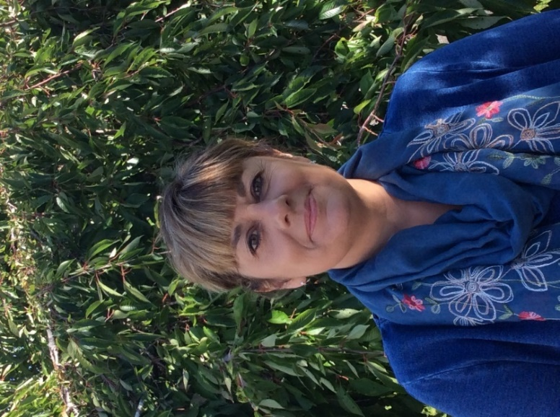

Miss Barnett Class 12
Mrs Stewart Class 11

Year 5 Curriculum Overview 2023 - 2024

Year 5 | Autumn 1  Rivers | Autumn 2  Vikings and Anglo Saxons | Spring 1  Shakespeare Production | Spring 2  European Volcanoes | Summer 1  WWII | Summer 2  Fairgrounds
History |  | Vikings and Anglo Saxons |  |  | WWII | WWII
Geography | Rivers |  |  | European Volcanoes and Earthquakes
Science | Materials Properties, Changing and Separating Materials | Electricity | Habitats/Lifecycles  Plants | Habitats / Lifecycles  Animals | Forces | Sex Education
Nutrition Cooking |  | Viking Stew | Bread |  | Rationing biscuits
DT |  |  | Bread |  | Make do and Mend – Soft toys | Fairgrounds- CAM toys
Art and Design | Printing : Rivers | Painting : Viking Seascape | Sculpture: People in motion | Still Life Drawing : Objects and Meaning | Textiles: Make Do and Mend | Sculpture: Natural Materials
Physical Education | Hockey  Shape and balance (gym) | Rugby  Viking dance | Cricket and Rounders  Responding to Music Dance (gym) | Football  Country dancing | Athletics  WW2 dance | Tennis  Key Steps Body Management (gym)
Heartsmart | Get Heartsmart | Don’t forget to let love in | Too much selfie isn’t healthy | Don’t run it in, rub it out | Fake is a mistake | No way through isn’t true
RE | Prayer (Islam) | Interpretation - Birth Stories (Christianity) | Stewardship  (Islam) | Salvation (Christianity) | Sacrifice  (Christianity/ links to WW2) | It’s a Good Life  (Humanism)
Music | Storm Interlude | Map rappers Christmas Carol Concert singing | Harry Potter Ostinato | Stomp | Eleanor Rigby | WW2
Computing | Vlogging | Creating STEM challenges | e-Safety – My Online Life | e-Safety  Animation | Augmented reality game making | Podcasts
MFL | Zoo Animals | TEXT: Cher Zoo | Numbers 1-60  Sports | Topic on France | French – WWII Unit - Le Depart | Days / Months  Seasons / Weather

Year 5 Educational Visit/Visitors 2022 - 23

Year 5 | Autumn 1 | Autumn 2 | Spring 1 | Spring 2 | Summer 1 | Summer 2
 | River trip to Selbourne Gilbert White  St Mary’s Church  Harvest | St Mary’s Church  Christmas | Shakespeare Workshop  (At school) | Shakespeare Performances | Paulton’s Park | Testbourne School

Year 5 Reading Key Objectives

Use a wide range of strategies to work out unfamiliar words
Read a range of non-fiction and modern fiction, from literary heritage and from other cultures/traditions
Make book recommendations about books, giving reasons for choices
Understand the conventions of different types of writing e.g 1st person in diary
Discuss themes and conventions across a wide range of writing
Explain and discuss understanding of reading using some technical terms e.g metaphor
Make comparisons within and across books
Summarise ideas drawn from more than one paragraph, identifying key details
Identify how language, structure and presentation contribute to meaning
Discuss understanding of texts, including exploring meaning of words in context
Discuss how authors use language, including figurative language, to affect the reader
Predict future events from details stated and implied
Participate in discussions about books, building on and challenging ideas

Year 5 Writing Behaviours & Key Objectives

Writing Behaviours:
Generate ideas through role play, oral retelling, presentation, performance and debate
Discuss, question and evaluate texts and writers’ choices of vocabulary and grammar to inform own writing
Plan writing with a clear audience and purpose drawing on example texts
Monitor and re-read own writing for accuracy and clarity, reflecting on composition and effect
Assess effectiveness of own writing and propose changes to enhance effect and clarify meaning
Key Objectives:
Apply taught spelling rules and knowledge in own writing
Use advanced organisational, cohesive and presentational devices
Use expanded noun phrases to convey complicated information concisely
Use the correct tense consistently throughout a piece of writing
Use relative clauses and commas to clarify meaning or avoid ambiguity
Use adverbials of time, place and number for cohesion
Recognise vocabulary and structures that are appropriate for formal use
Describe setting, atmosphere and characters effectively for the reader
Use brackets, dashes and commas to indicate parenthesis
Use modal verbs or adverbs to indicate degrees of possibility

Maths Mastery

The National Curriculum emphasises the importance of all children mastering the content taught each year and discourages the acceleration of children into content from subsequent years.
We aim for all children to
• become fluent in the fundamentals of mathematics, experience varied and frequent practice with increasingly complex problems over time in order to develop conceptual understanding and the ability to recall and apply knowledge rapidly and accurately
• reason mathematically by following a line of enquiry, spotting relationships and generalisations, and developing justification or proof using mathematical language
• solve problems by applying their mathematics to a variety of routine and non-routine problems with increasing sophistication, including breaking down problems into a series of simpler steps and persevering in seeking solutions.

Year 5 Key Objectives
Recognise and use square and cube numbers, and know the notation
Use rounding to check answers and determine accuracy
Identify multiples and factors, including finding factor pairs and common factors
Interpret negative numbers in context
Know prime numbers up to 19
Multiply and divide numbers by 10, 100 or 1000, including decimals
Use long multiplication for multiplying numbers of up to 4 digits by one or two digits
Divide numbers using standard written short division
Compare and order fractions & convert between mixed numbers and improper fractions
Identify, name and write equivalent fractions including tenths and hundredths
Add and subtract fractions with denominators that are multiples of the same number
Read and write decimal numbers as fractions
Round decimals with 2 decimals places to whole number or to one decimal place
Read, write, order and compare numbers with up to 3 decimal places
Recognise % symbol and explain as a fraction with denominator 100 (parts out of 100)
Measure and calculate the perimeter and area of shapes
Draw and measure angles to the nearest degree
Complete, read and interpret information in tables, including timetables
Distinguish between regular and irregular polygons

Year 5 Science Key Objectives

Plan scientific investigations, including controlling variables where appropriate
Record data using diagrams, keys, tables and a range of graphs
Report conclusions and explanations from scientific investigations
Describe the life process of reproduction in some plants and animals.
Explain how mixtures can be separated through filtering, sieving and evaporating
Explain that some irreversible changes form new materials
Explain how the number of voltage of cells affects bulbs, buzzers or motors in a circuit
Use recognised symbols when representing a simple circuit in a diagram.
Explain that gravity causes unsupported objects to fall towards the Earth
Identify the effects of air resistance, water resistance and friction between moving surfaces

Year 5 Spelling

Statutory requirements |  | Rules and guidance(non-statutory) | Example words (non-statutory)
Words ending in –able and  –ible  Words ending in –ably and  –ibly |  | The –able/–ably endings are far more common than the –ible/–ibly endings.  As with –ant and –ance/–ancy, the –able ending is used if there is a related word ending in –ation.  If the –able ending is added to a word ending in –ce or –ge, the e after the c or g must be kept as those letters would otherwise have their ‘hard’ sounds (as in cap and gap)before the a of the –able ending.  The –able ending is usually but not always used if a complete root word can be heard before it, even if there is no related word ending in –ation. The first five examples opposite are obvious; in reliable, the complete word rely is heard, but the y changes to i in accordance with the rule.  The –ible ending is common if a complete root word can’t be heard before it but it also sometimes occurs when a complete word can be heard (e.g. sensible). | adorable/adorably (adoration),  applicable/applicably (application), considerable/considerably (consideration), tolerable/tolerably (toleration)  changeable, noticeable, forcible, legible  dependable, comfortable, understandable, reasonable, enjoyable, reliable  possible/possibly, horrible/horribly, terrible/terribly, visible/visibly, incredible/incredibly, sensible/sensibly
Words containing the letter-string ough |  | ough is one of the trickiest spellings in English – it can be used to spell a number of different sounds. | ought, bought, thought, nought, brought, fought  rough, tough, enough  cough  though, although, dough  through  thorough, borough  plough, bough

Year 5 Spelling (cont’d)

Statutory requirements |  | Rules and guidance(non-statutory) | Example words (non-statutory)
Words with ‘silent’ letters (i.e. letters whose presence cannot be predicted from the pronunciation of the word) |  | Some letters which are no longer sounded used to be sounded hundreds of years ago: e.g. in knight,there was a /k/ sound before the /n/, and the gh used to represent the sound that ‘ch’ now represents in the Scottish word loch. | doubt, island, lamb, solemn, thistle, knight
Homophones and other words that are often confused |  | In the pairs of words opposite, nouns end –ce and verbs end –se. Advice and advise provide a useful clue as the word advise (verb) is pronounced with a /z/ sound – which could not be spelt c | advice/advise  device/devise  licence/license  practice/practise  prophecy/prophesy

Year 5 Grammar & Punctuation

Sentence Structure
Relative clauses beginning with who, which, where, when, whose, that, or an omitted relative pronoun
Indicating degrees of possibility using adverbs [for example, perhaps, surely] or modal verbs [for example, might, should, will, must]

Text Structure
Devices to build cohesion within a paragraph (e.g. then, after that, this, firstly)
Linking ideas across paragraphs using adverbials of time [for example, later], place [for example, nearby] and number [for example, secondly] or tense choices

Punctuation
Brackets, dashes or commas to indicate parenthesis
Use of commas to clarify meaning or avoid ambiguity

Terminology for Pupils
modal verb, relative pronoun, relative clause, parenthesis, bracket, dash, cohesion, ambiguity

Behaviour Policy
We have chosen three rules through which the code of conduct is promoted in all aspects of school life.
Be
• Ready
• Respectful
• Safe

Incentives and Rewards
A major aim of the school policy is to encourage children to practice good behaviour by operating a system of recognition and reward. All staff give verbal or written recognition as often as possible. Other rewards include:
- Positive notes home
- Beads in a bottle (class reward)
- Certificates
- Hot Chocolate Fridays
- VIP wrist bracelets (Over and above)
The mindfulness room
At breaktimes and lunchtimes, a calm room is available for children to come to if they are feeling angry or upset and need to calm down.
Sanctions
Our sanctions policy concentrates on encouraging children to make sensible choices and putting things right when possible. If a child breaks a school rule (e.g. by disturbing others through chatting, calling out etc) the ‘Sanctions Ladder’ should be followed with children moving to the next point on the ladder if the behaviour continues or worsens.
Before going on to the “ladder”, the teacher will notice by giving the child a look or let the child know that they are making a poor choice.
If the child continues to break school rules…
1. Reminder
2. Warning
3. Time out or move in class
4. Repair (discuss behaviour with teacher and consider how best to repair the problem)

If you are sent out of your classroom, your teacher will speak to your parents.
If your behaviour does not improve you will discuss this with your class teacher and Head Teacher and your parents will be contacted.
Repeated classroom disruption may result in a behaviour chart or plan being implemented.
If a child wastes time or does not complete work that has been set, the work will be completed in the child’s own time i.e. at break or lunchtime.

Serious Breaches of the Behaviour Policy
For more serious behaviour e.g. swearing, spitting, causing physical harm, damaging school property, which goes beyond the breaking of class rules, the adult dealing with the situation will need to use their professional judgement over the best course of action ensuring the safety of children and staff first.

